Name: D.Bala Charan Roll No:2520090087

Practical week - 6

routes/catalog.py :
from fastapi import APIRouter, HTTPException router = APIRouter()
books = [
{
"id": 101,
"title": "Python Programming", "author": "John Smith", "price": 450,
"isbn": "9781234567890",
"status": "Available"
},
{
"id": 102,
"title": "Database Management", "author": "Robert Brown", "price": 550,
"isbn": "9789876543210",
"status": "Available"
}
]
@router.get("/books") def get_books():
return books

@router.get("/books/{book_id}") def get_book(book_id: int):
for book in books:
if book["id"] == book_id:
return book raise HTTPException(
status_code=404, detail="Book not found"
)

routes/admin.py :
from fastapi import APIRouter, HTTPException from pydantic import BaseModel, Field
from routes.catalog import books router = APIRouter()

class Book(BaseModel):
title: str author: str
price: float = Field(ge=0) isbn: str
status: str

@router.post("/admin/books") def add_book(book: Book):
new_id = max([b["id"] for b in books], default=100) + 1 new_book = {
"id": new_id, book.model_dump()
}
books.append(new_book) return {
"message": "Book added successfully", "book": new_book
}

@router.put("/admin/books/{book_id}") def update_book(book_id: int, book: Book):
for index, existing_book in enumerate(books): if existing_book["id"] == book_id:
updated_book = { "id": book_id,
book.model_dump()
}
books[index] = updated_book return {
"message": "Book updated successfully", "book": updated_book
}
raise HTTPException( status_code=404, detail="Book not found"
)
@router.delete("/admin/books/{book_id}") def delete_book(book_id: int):
for index, book in enumerate(books): if book["id"] == book_id:
deleted_book = books.pop(index)
return {
"message": "Book deleted successfully", "book": deleted_book
}
raise HTTPException( status_code=404, detail="Book not found"
)

main.py :
from fastapi import FastAPI
from routes.catalog import router as catalog_router from routes.admin import router as admin_router app = FastAPI(
title="BookFlow Library API"
)
app.include_router(catalog_router) app.include_router(admin_router)

GET default all the data:
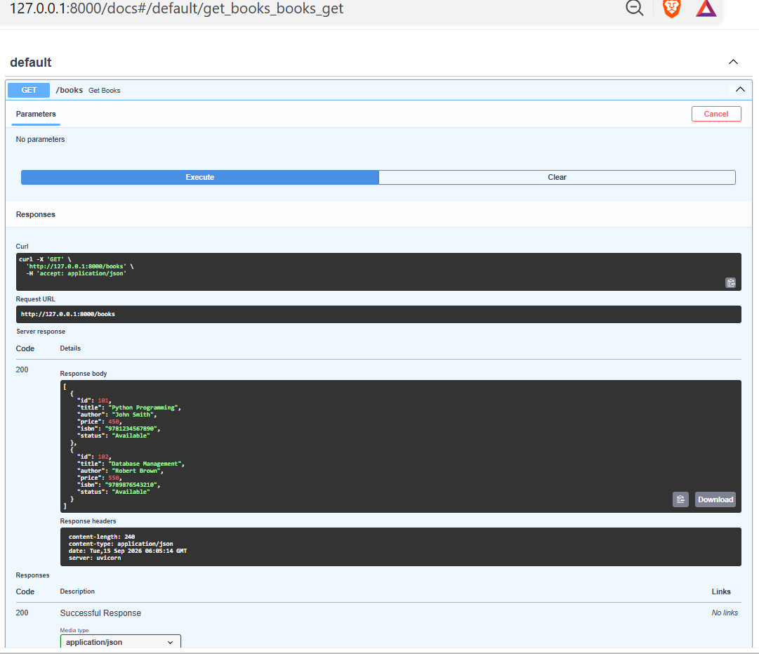

GET:
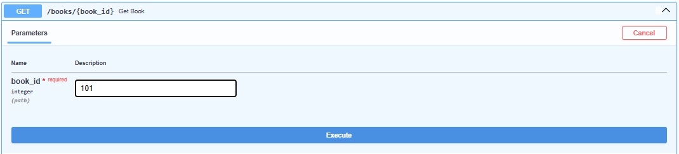

Response:
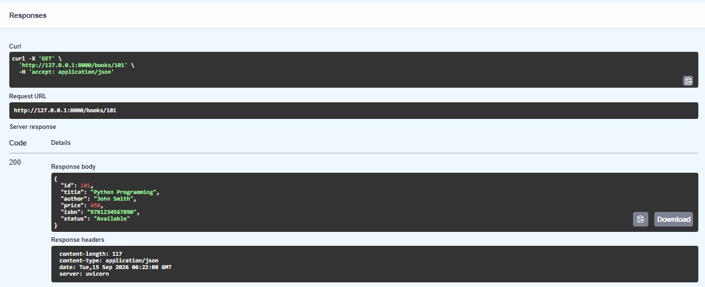

POST:
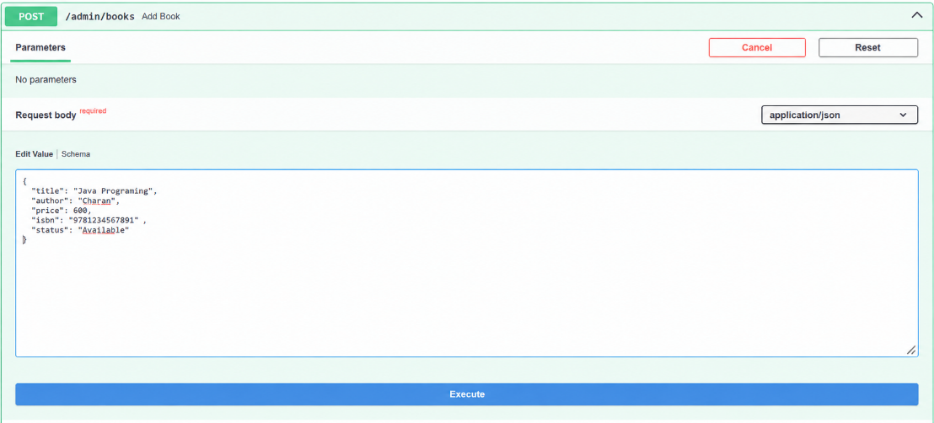

Response:
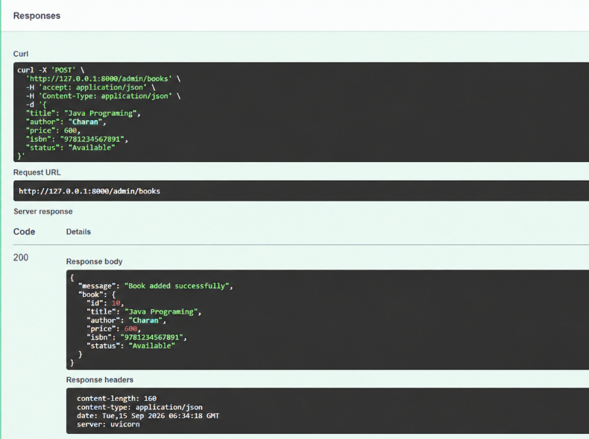

PUT:
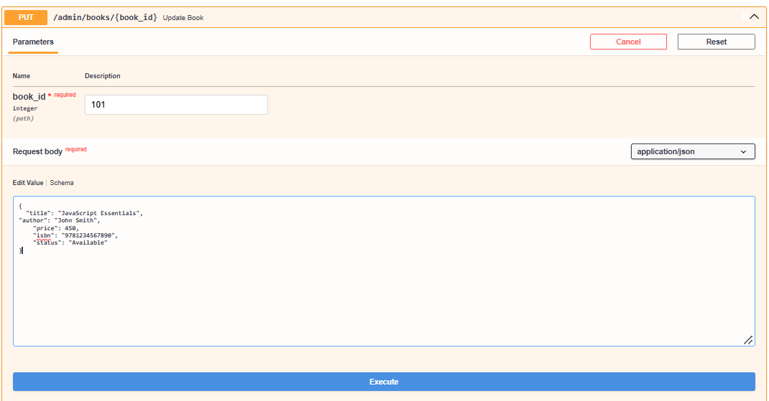

Response:
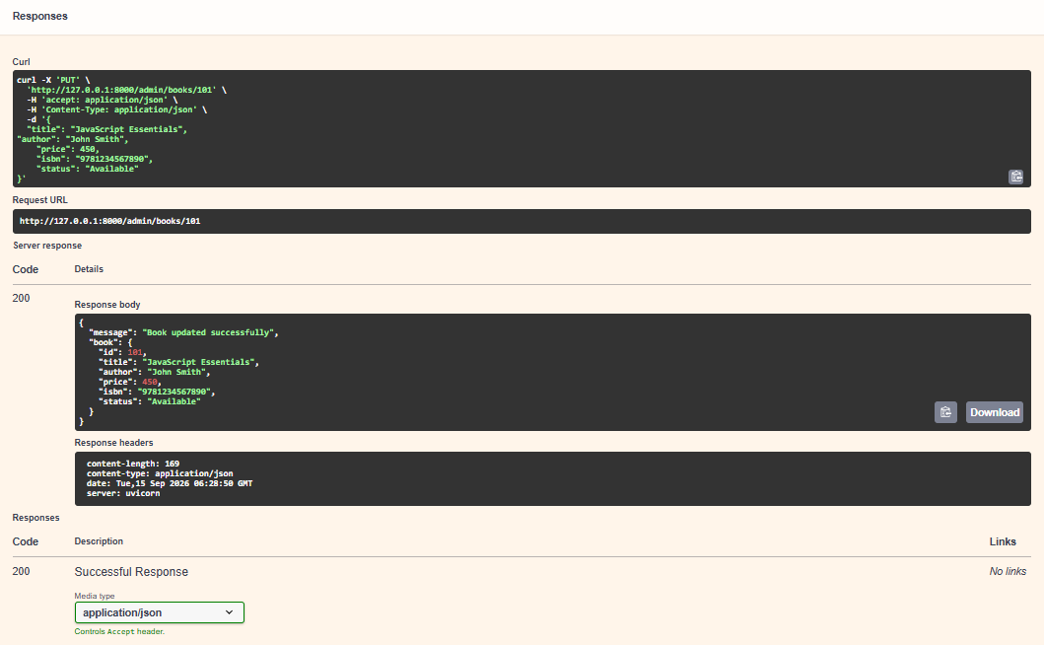

DELETE:
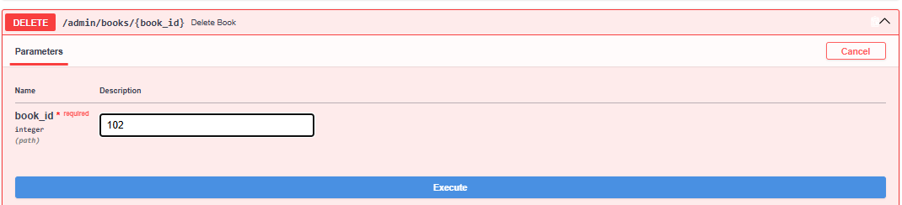

Response:
